**Create And Configure IBM Cloud Service**

**Create A Database in Cloudant DB**

# IBM-Project-27598-1660060762

# Team Leader : Dheepakraj P

# Team Member : Dhachayani K

# Team Member : Divi Sushma

# Team Member : Srinivasa Reddy D

**AIM**

To create a database in Cloudant DB to store location data

# STEPS

1.Login to IBM Cloud with smart internz mail ID and Password.

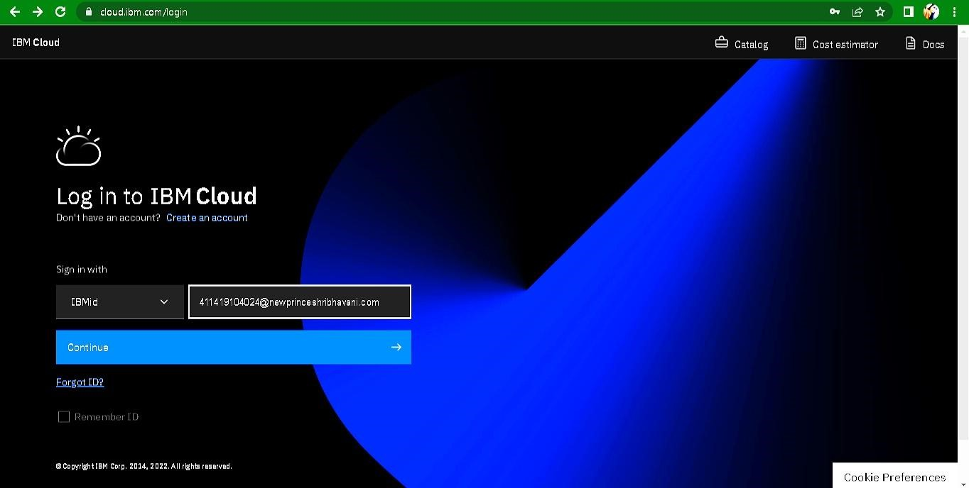

1. Click “Create Resource +” button

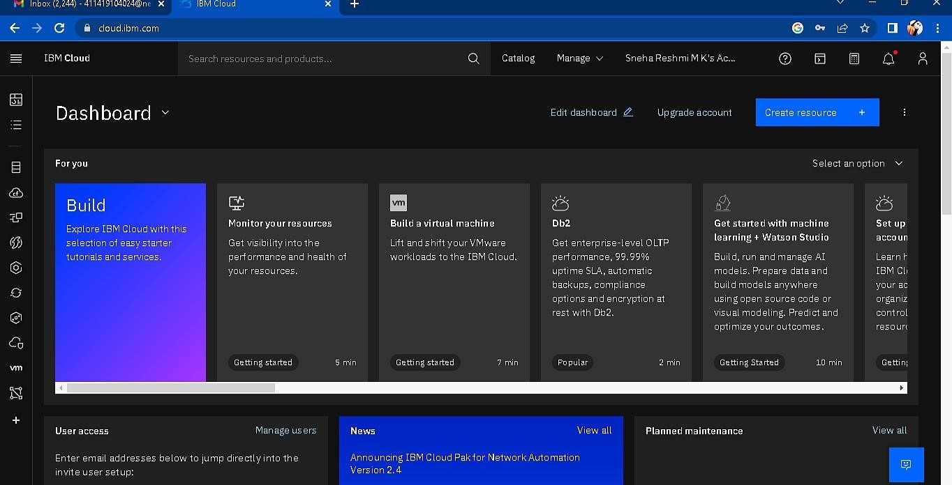

1. Search Cloudant in Catalog then Choose the Lite version

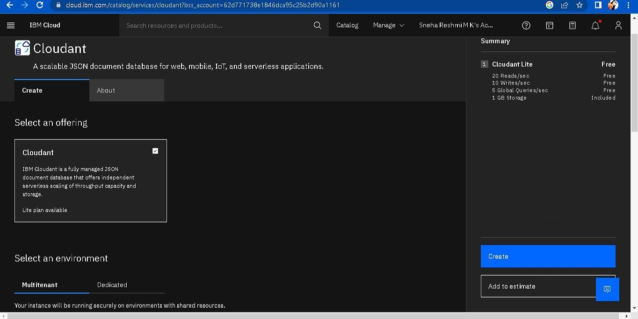

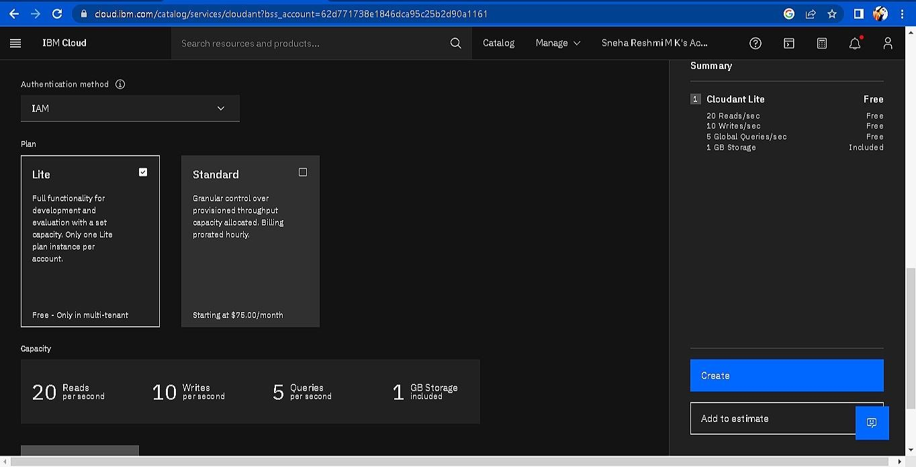

1. The Cloudant database resource created

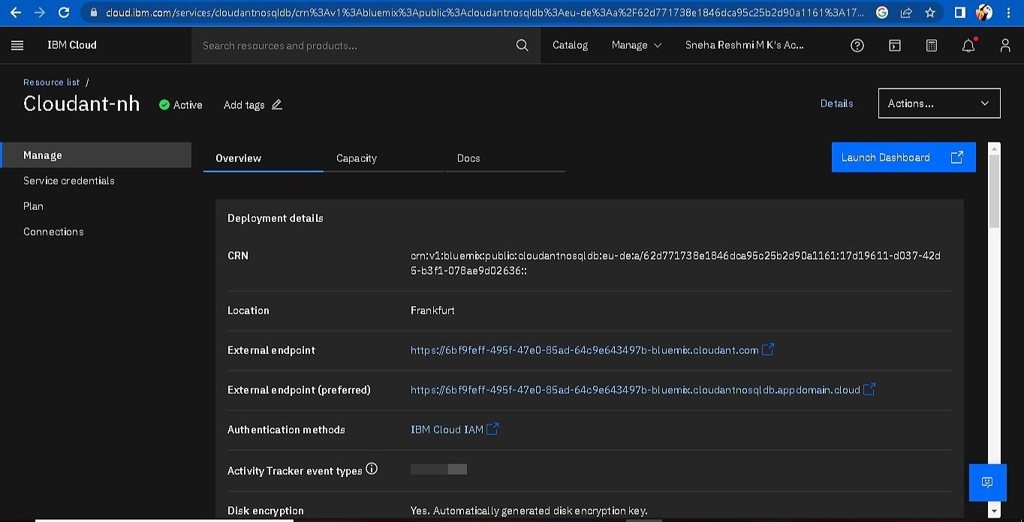

1. click on launch dashboard

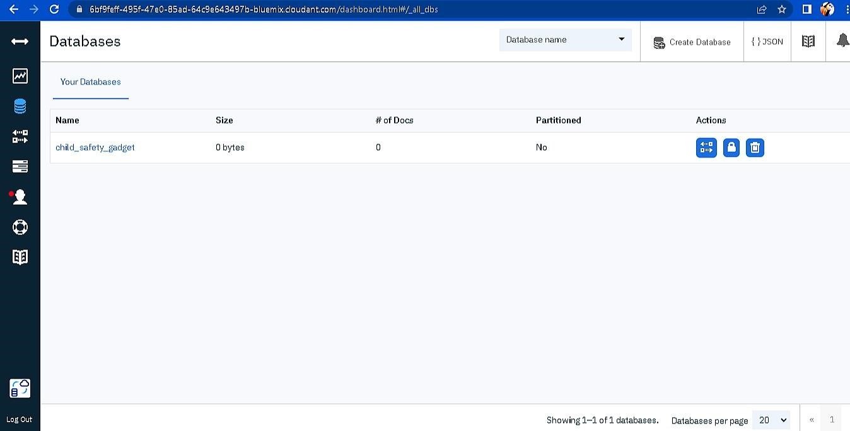

8.Click “Create Database”. Entered “child_safety_device” as the database name and the “Non-partitioned” option.

9. The database “child_safety_device” has been created and it's work Successfully

**RESULT**:

A database to store the location data on Cloudant DataBase has been created successfully.